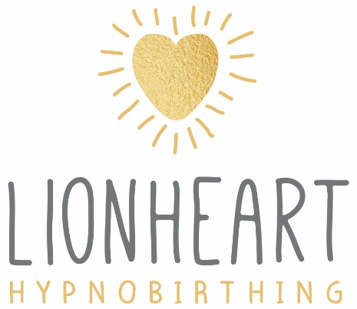

Terms and Conditions – Virtual Courses
Booking
A booking does not constitute the creation of a contract and the teacher reserves the right to decline to process a booking for any reason whatsoever. If the booking is not able to be fulfilled the teacher will promptly refund all monies.
Refunds
If your baby arrives before the course begins, a refund will be repaid in full. Should your baby arrive part way through the course, the teacher will make a partial refund using her professional discretion; taking into account how many sessions have already occurred. If, however, you have booked on to the course knowing that you will have reached 37 weeks gestation and beyond at any point during the course, this refund will not apply.
If you are unable to attend a live session/s, no refunds will apply for that missed session. You have the option to book this as a “private” session at an additional cost of £45.
Course Cancellation
The teacher reserves the right to amend or cancel any course, course times, dates.
In the very unlikely event of a session needing to be rescheduled by the teacher, the teacher will do her utmost to accommodate as many participants as possible when re-booking a date/dates. If you are unable to attend the rescheduled live session/s, no refunds will apply if a live rescheduled session is missed by a participant.
In the event of the course being cancelled, a full refund will be provided to participants.
Intellectual Property
Any resources included as part of this course or arising from the course may not be used other than for personal use of the attendees. The attendee agrees not to record the course or any part of it, and also agrees to not forward any materials on to a third party.
Data Protection
You agree that the teacher shall hold your details on file and on computer and, in accordance with the Data Protection Act 1998, you are able to view your individual file by not giving less than seven days’ written notice.
As a hypnobirthing teacher, I:

- Do not make decisions for you
​
The Hypnobirthing course is not a substitute for medical advice. All information given is information only. Whilst I am happy to talk things over with you, you and your medical professionals are the only decision makers regarding your pregnancy, labour and birth.

If you have any concerns regarding your health and well-being, or that of your baby, please contact your midwife or doctor.

- Am not present during your labour and birth

The hypnobirthing course is antenatal education only. I will not be present during your labour or for your baby’s birth.

Disclaimer
Hypnobirthing techniques increase the likelihood of a more straightforward and more comfortable labour and birth. However, this is not a certainty. Furthermore, using Hypnobirthing techniques is not a substitute for the advice of, or the presence during birth or any part of pregnancy or labour, of a qualified medical practitioner, midwife or obstetrician. It does not represent fact or otherwise an alternative to appropriate medical care or for professional medical advice in any way.
Any questions or doubts that you have about the use of Hypnobirthing by you or any third party in any part should be discussed by you with your medical caregiver, and the safety and appropriateness of this programme to you or any third party whom you represent be confirmed with your medical caregiver prior to undertaking the programme.

-

Terms and Conditions – Face to Face
Booking
A booking does not constitute the creation of a contract and the teacher reserves the right to decline to process a booking for any reason whatsoever. If the booking is not able to be fulfilled the teacher will promptly refund all monies.
Payment
A non-refundable £50 deposit is required to secure booking and full payment is required prior to course commencement. Payment in full can also be taken upon booking.
Refunds and Participant Cancellation
If your baby arrives before the course begins, or in the very unlikely event of the course being cancelled, payment will be repaid in full. These are the only circumstances under which a full refund will be made.
Should your baby arrive part way through the course, the teacher will make a partial refund using her professional discretion; taking into account cost of merchandise/resources given/room hire etc and how many sessions have occurred. If, however, you have booked on to a course knowing that you will have reached 37 weeks gestation and beyond at any point during the course, this refund will not apply.
If you are unable to attend a planned session/s, course materials will still be provided for you. You can re-book this session at a date/time to suit you and the teacher. This will incur an additional cost of £50 per session. If you live further that a 20mile return journey from the teacher’s home (in the WA10 area) additional fuel costs will be also added.
Course Cancellation
The teacher reserves the right to amend or cancel any course, course times, dates or published prices. Changes to course prices, times and dates will be advised before the course start date and any course already paid for (deposit or in full) will not be subject to any price changes.
Should a group session need to be cancelled by the teacher, the teacher will re-book this session either as another group or individually, with no additional cost to you.
Intellectual Property
Any recording or written material included as part of this course or arising from the course may not be used other than for personal use of the participant without obtaining prior written permission. The participant agrees not to record the course or any part thereof.
Data Protection
You agree that the teacher shall hold your details on file and on computer and, in accordance with the Data Protection Act 1998, you are able to view your individual file by not giving less than seven days’ written notice.
As a hypnobirthing teacher, I:

- Do not make decisions for you
​
The Hypnobirthing course is not a substitute for medical advice. All information given is advice only. Whilst I am happy to talk things over with you, you and your medical professionals are the only decision makers regarding your pregnancy, labour and birth.

If you have any concerns regarding your health and well-being, or that of your baby, please contact your midwife or doctor.

- Do not perform any clinical tasks

Whilst I am a registered health professional, in this role as hypnobirthing teacher it is not within my remit to perform any assessments or examinations. These are the responsibilities of the midwife and doctor caring for you and your baby.

- Am not present during your labour and birth

The hypnobirthing course is antenatal education only. I will not be present during your labour or for your baby’s birth.

Disclaimer
Hypnobirthing techniques increase the likelihood of a more straightforward and more comfortable labour and birth. However, this is not a certainty. Furthermore, using KG Hypnobirthing techniques is not a substitute for the advice of, or the presence during birth or any part of pregnancy or labour, of a qualified medical practitioner, midwife or obstetrician. It does not represent fact or otherwise an alternative to appropriate medical care or for professional medical advice in any way.
Any questions or doubts that you have about the use of KG Hypnobirthing by you or any third party in any part should be discussed by you with your medical caregiver, and the safety and appropriateness of this programme to you or any third party whom you represent be confirmed with your medical caregiver prior to undertaking the programme.

